
MyCanadianCompLab Quick Start Kit Contents:

- MyCanadianCompLab Overview
- Quick Start Guide to MyCanadianCompLab
- Instructor Support and Training
- MyCanadianCompLab FAQs
- Faculty Sample Syllabi

MyCanadianCompLab Overview
MyCanadianCompLab empowers student writers and facilitates writing instruction by uniquely integrating a composing space with proven resources and tools. In this revolutionary application, students receive feedback within the context of their own writing—encouraging critical thinking and revision while honing their skills based on individual needs. Administrative features developed specifically for writing instruction bring instructors closer to their student writers, make managing assignments and evaluating papers more efficient, and save instructors time.

MyCanadianCompLab Quick Start

How to register an instructor access code (if your representative has not already created an account for you)
- Go to www.mycanadiancomplab.ca.
- In the "Register or Buy Access" box, click Instructors.
- Click I already have an access code.
- Click I accept after reading the Pearson License Agreement and Privacy Policy.
- Do you have a Pearson Education account?
  - If Yes – Fill in your login name and password (TIP! You can use the same login in and password that you are using for your other Pearson products.
  - If No – Create a login and password per the guidelines provided.
  - If Not Sure – Enter your email address and click Search.
- Enter your access code and click Next.
- Enter or select the required information in the appropriate fields.
- Review and print your Confirmation and Summary page (a confirmation will also be sent to your email address). TIP! Be sure to take note of your login name and password—write them down or save them on your computer in a place you will not forget.
How to log in
- Return to the MyCanadianCompLab home page.
- In the "Returning Users" box, click Log In.
- Enter your Login name and Password in the fields provided.
- Click Login.

How to create a course
- Follow the Login instructions above.
- Click Create a Course.
- Step 1 -- Choose your course type
  - Use either the MyCanadianCompLab generic course or a book-specific (eBook) version (this is the most popular choice).
  - Copy or link to a course from your course list (you can copy or link to one of your existing courses).
  - Copy or link to a course from the public course list (allows you to copy or link to other instructors' courses).
- Depending on your choice in Step 1, find the product or course to copy or link to. Then select the product or course and click Continue.
(TIP! View all courses in a list or search by author, ISBN or title.)
- Step 2 – Define your settings.
  - Enter a course title.
  - Enter a section name.
  - Enter the course start date.
  - Enter the end date. (NOTE! Your course will be archived at 11:59 p.m. on the end date).
  - Choose your time zone and click Continue.
- Step 3 – Set student access properties.
  - Make course available to students – Select Yes unless you want to prevent access.
  - Set a password – Optional setting and not necessary for most courses. (Requires that students enter a password before getting access to the course.)
  - Enable Pearson Tutor Services – Select Yes to give students access to 24/7 tutoring.
  - Enable Noodle Bibliography Builder – Select Yes to give students access to notetaking and citation tools.
- Step 4 – Copy course properties.
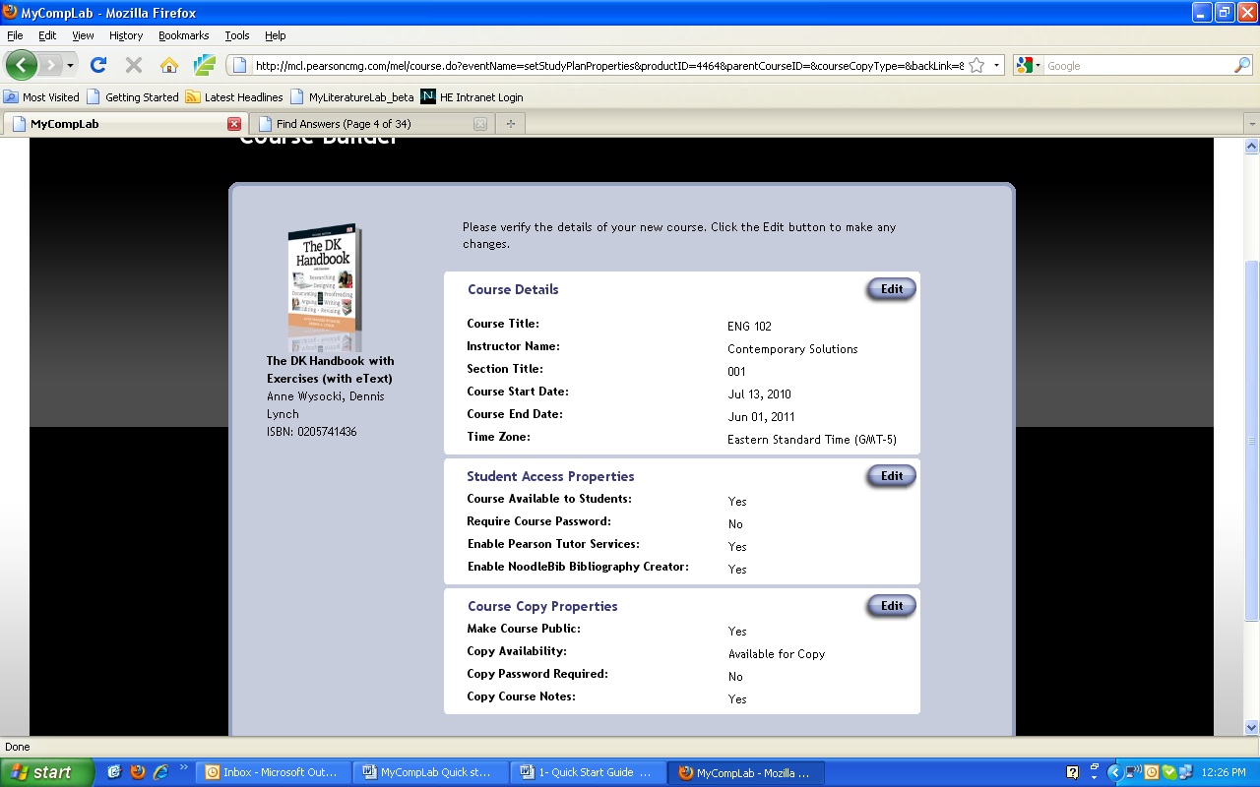
  - Make course public – Select Yes to allow other MCL instructors to copy or link to your course.
  - Course copy availability – Select whether other instructors can copy or link to your course. (This option is available only if you selected Yes for "Make course public."
- Step 5 — Copy Assignments. If this new course is a copy or a link to an existing course, select the original course's assignments that you want in the new course.
NOTE! Assignments included in copied or linked courses need to be activated. Look up assignments, setup of in the online Help index for further details.
- Step 6 – After you click continue MyCanadianCompLab displays all of your course settings. Review and edit the settings as needed, then click Continue. MyCanadianCompLab creates the course and displays the congratulations page. Note the Course ID at the top of the page.
IMPORTANT! Your students need the course ID in order to join your course. You need to distribute the Course ID to your students.
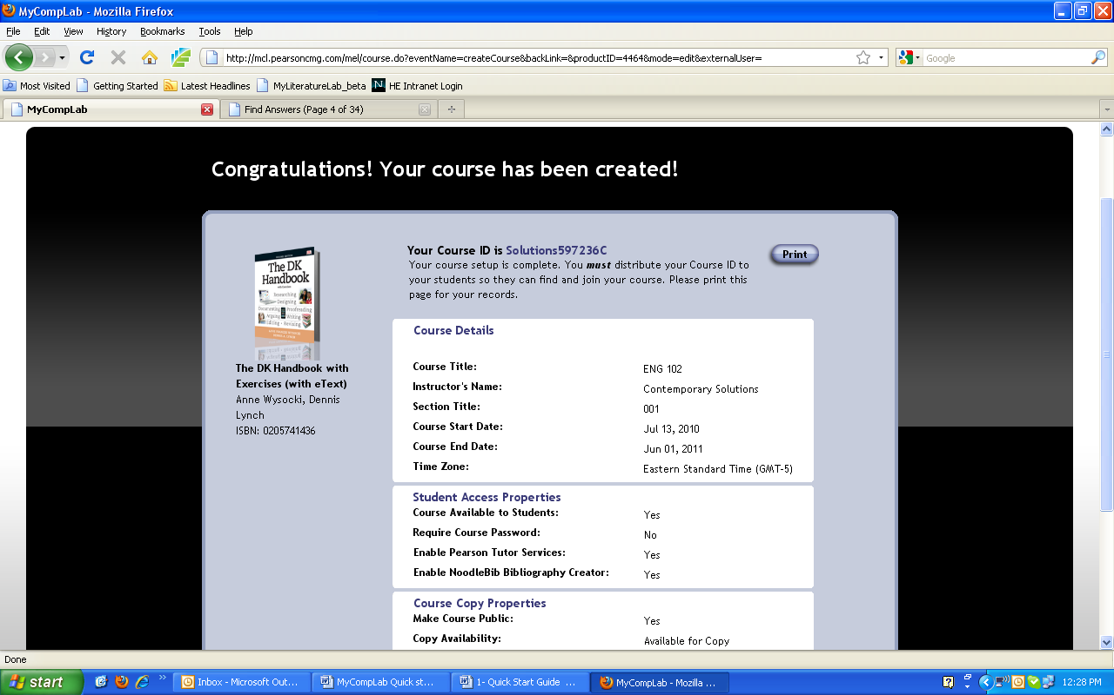
How to assign self-diagnostics to your students:
- Look at the Student View of the Home tab. Decide which diagnostic you want your students to take and include it on your syllabus.
- Your students will click the diagnostic you want them to take from the home page.

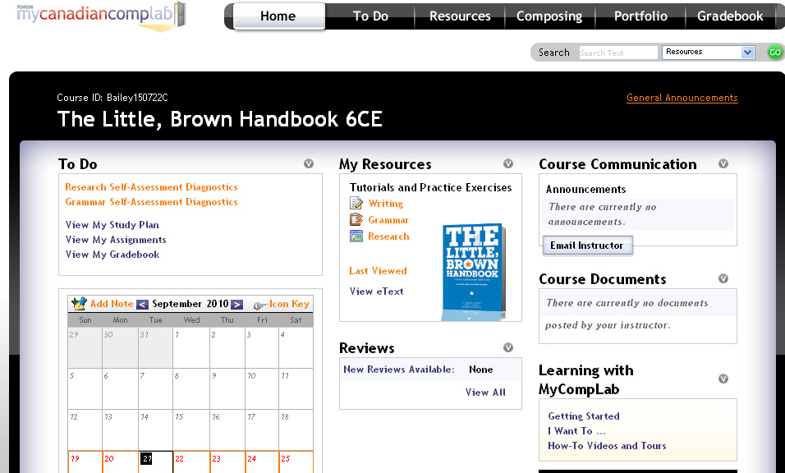

How to create an assignment
- Follow the Login instructions above.
- Click the Assignments tab.
- Click Create Assignment.
- Choose the type of assignment you'd like to create (Composition, Collaboration, Peer Review, Portfolio, Skill Building or Diagnostics).
- Click Continue.
- Follow the onscreen instructions to complete the assignment details, including title, prompt, start date, end date and other information as appropriate (NOTE! Each assignment requires different information but uses the same wizard to build assignments.)
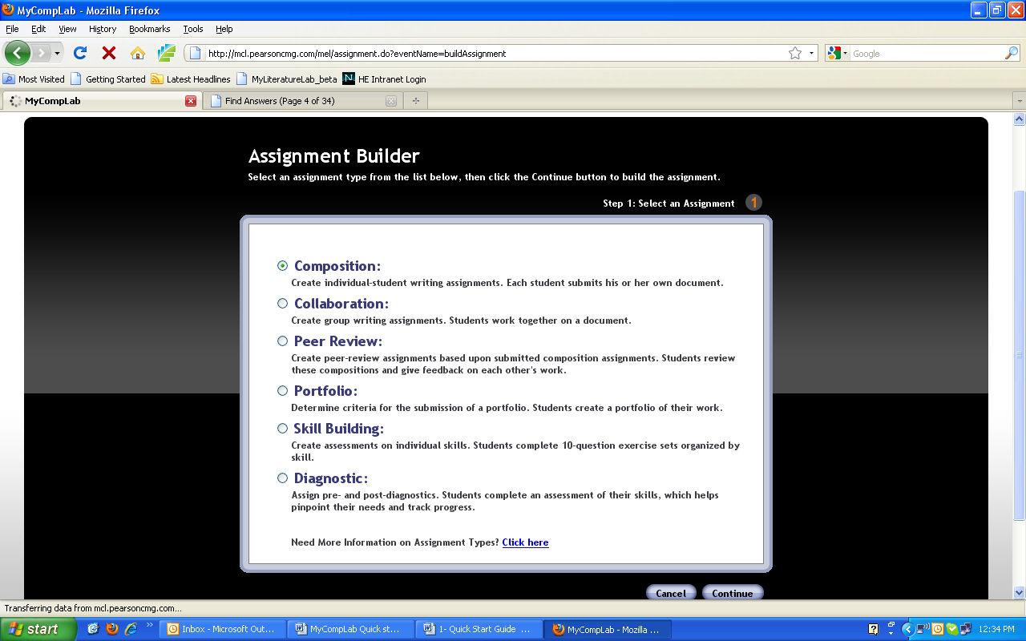

Training and Technical Support
At Pearson, we take your technical needs and questions very seriously. We are committed to giving instructors and students technical support when they need it, no matter what. Therefore, we offer technical support 24 hours a day, 7 days a week.

Customer Technical Support at
http://247pearsoned.custhelp.com
- Search frequently asked questions.
- Ask a question and receive a detailed response.
- Chat online with a live representative.

Live, Online Training at
http://www.mycanadiancomplab/training.html
- We offer live, online training sessions for MyCanadianCompLab weekly.
- Join one of our training webinars and learn how to use the application from a member of our media team.
- Review our webinar schedule and learn more about our training options.

Detailed How-To Videos at
http://www./mycanadiancomplab/howto.html
- Watch videos that provide you with convenient how-to instructions for some of MyCanadianCompLab’s most popular tasks.
- How-to videos are available for both instructors and students.

MyCanadianCompLab FAQs

How do my students join a different course?
STEP 1: Prepare Documents
Open documents attached to an assignment and resave them as personal documents. There are two options for doing this. Log into your existing course and follow these steps:
STEP 2:
- Go to Composing and click on the Files menu.
- Click Open Document and select the Assignment Document you wish to convert to a Personal Document.
- From the Choose an Action drop down menu, choose Open a Copy.
- Click on the Files menu and then click on Save.
- Repeat for all assignment documents.
STEP 3: Join a New Course
Log into your existing course and follow the instructions below:
- Click on Settings.
- Select Join a Different Course.
- Select Join Your Instructor's Course.
- Enter the Course ID for the new course, or use the search options to find your instructor's course.
- Select the correct course.
- Click on Click Here to Start Working.

How do students add a document that was created in another program?
- Click on the Composing tab
- Point to the Files button
- Select Upload Document
- Select the desired file from your drive
- Click Submit to load the file into the composing space
How do students save a document that they’re currently working on in the composing space?
- From the composing space, point to the Files button
- Select Save to save the document to our servers and continue working
- Select Save and Close if you want to save the document and get a clear screen

How do students load a saved document?
Option 1
- From the Composing Space, point to the Files button
- Select the desired document
- Click Go
- The document will open in the composing space

Option 2
- Click on the To Do tab
- Click on My Documents
- Select the desired document
- The document will open in the composing space

How do I access SmartThinking Tutor in MyCanadianCompLab?
Instructors can click on Tutor in the Composing section to see a description of Pearson Tutor Services. The tutor service can be accessed via student accounts only. Students access the tutor service by clicking on Tutor in the composing space. A form will come up, asking the purpose of the assignment and what the student wants the tutor to look for. Student's place a checkmark by two specific items that they want to tutor to focus on.tudents can submit to the SmartThinking Tutor up to six times per access code and course. Once the six-submission limit has been reached in a course, there is not a way to add more submissions while in that course.

Can I reset skill-building exercises so students can try again for a new grade?
Once the skill-building assignment is assigned and completed, it is done. You cannot re-release for them to complete again or reassign that particular activity.

Any grammar activity that the students complete on their own in the grammar resources section can be reset by the instructor to complete again. These self-paced exercises are what appear in your "practice" grade book.
MyCanadianCompLab Student Registration Instructions

Before You Begin
To register for MyCanadianCompLab, you will need:
- Your school’s zip code: ___________________
- A MyCanadianCompLab student access code (packaged with your new text, available standalone at your bookstore, or available for purchase with a credit card at www.mycanadiancomplab.ca ).
- A valid email address.
In addition, your instructor will provide you with:
- A Course ID needed to join your instructor’s course. ___________

Registration and login
How to get a student access code:
- With your textbook. Receive an access code card when you purchase a new Pearson English textbook or check with your bookstore to purchase a standalone access code card.
- Purchase access online.
  - Go to www.mycanadiancomplab.ca .
  - Click Students in the “Register or Buy Access” box.
  - Click I need to buy access.
  - Select the version of MyCanadianCompLab that your instructor is using, generic or eBook. Ask your instructor if you’re not sure which version to choose.
  - If you select Generic you’ll need to select your length of access.
  - If you select E-Book Version, select the correct author and title carefully (take care to select the correct text).
  - Continue by jumping to the step below that begins with this symbol .

How to register a student access code:
- Go to www.mycanadiancomplab.ca .
- Click on Students in the “Register or Buy Access” box
- Click I already have an access code
-  Read the Pearson License Agreement and Privacy Policy and click the I Accept button.
- Do you have a Pearson Education account?
  - If Yes – Fill in your login name and password. (TIP! You can use the same login in and password that you are using for your other Pearson products.)
  - If No – Follow the onscreen instructions to create a login name and password.
  - If Not Sure – Enter your email address and click Search.
- Enter your access code in the boxes provided and click Next.
- Enter and select the required information in the appropriate fields on the next page and click Next.
- Review and print your Confirmation and Summary page (a confirmation will also be sent to your email address).

TIP! Be sure to take note of your login name and password—write them down or save them on your computer in a place you will not forget

How to login:
- Go to www.mycanadiancomplab.ca .
- Click Login in the “Returning Users” box.
- Enter your Login Name and Password in the fields provided.
- Click Login.

Getting started
How to join a course:
- Login at www.mycanadiancomplab.ca .
- Click Join Your Instructor’s Course.
- Type the Course ID into the field provided and click Submit. (You get the Course ID from your instructor.)
- Click the Start Working button or access the “How do I use MyCanadianCompLab?” User Guide.

NOTE! If you’re not using MyCanadianCompLab as part of a course or if you do not have your instructor’s Course ID, choose Work on Your Own. You can join your instructor's course any time from the MyCanadianCompLab Settings page.

NOTE! If you join the wrong course, while in MyCanadianCompLab click the Settings button, click Join a Different Course, click Join Your Instructor’s Course and enter the Course ID of the course you wish to join.

How to manage your assignments and writing:
- Click the To Do tab at the top of your screen.
- Click the All tab and select My Assignments to view due and completed assignments. Click My Documents to view a list of your documents. Click My StudyPlan to review suggested resources.
OR Click the Calendar tab to view your assignments by due date.

- Click an assignment title to view the assignment's details, including with specific instructions from your instructor. Then click the Begin Working/Resume Working button to begin or continue working on that assignment.

NOTE! Assignments are available only in instructor-led courses and only if your instructor has created assignments.

Introduction to other features:
- HOME – Access and personalize a snapshot of your MyCanadianCompLab work.
- RESOURCES – Learn about and practice grammar, writing, and research skills.
- COMPOSING – Compose or upload your documents in a familiar word processor with writing support at your fingertips.
- PORTFOLIO – Organize, share and publish your documents for various audiences.
- GRADEBOOK – Track your progress over time.

Need help?
Go to www.mycanadiancomplab.ca and click the SUPPORT tab for additional registration information and direct links to technical support.

We wish you success in your course!

